Ideation Phase
Empathize & Discover

Date | 27 june 2025
Team ID | NM2025TMID00021
Project Name | Streamlining Ticket Assignment for Efficient Support Operations
Maximum Marks | 4 Marks

Empathy Map Canvas:
In the Empathize & Discover phase, the team observes how support agents and managers handle ticket assignment and tracking in the support system. They learn that many agents feel overwhelmed when tickets are assigned manually or unevenly distributed. By interviewing support staff, the team discovers that unclear prioritization, delayed responses, and repeated reassignments cause frustration, reduce efficiency, and lower customer satisfaction.

Gathering these insights helps the team understand the real impact on productivity and service quality. Understanding the users’ daily challenges reveals the need for an intelligent, automated, and balanced ticket assignment mechanism. These discoveries guide the design of solutions that are practical, data-driven, and user-friendly.
Example:
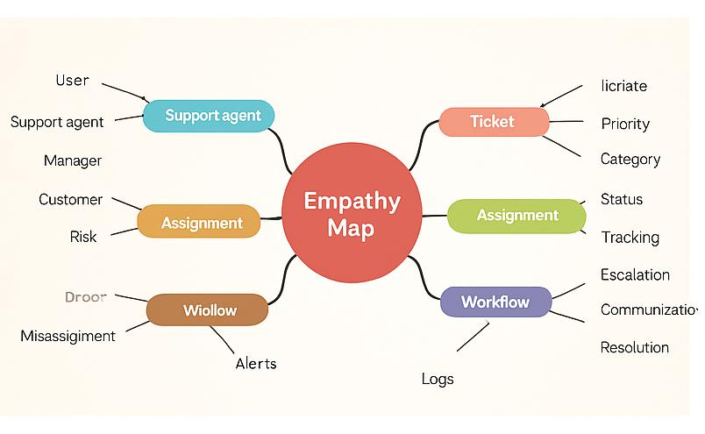

Reference: https://www.mural.co/templates/empathy-map-canvas

Example: Streamlining Ticket Assignment Application
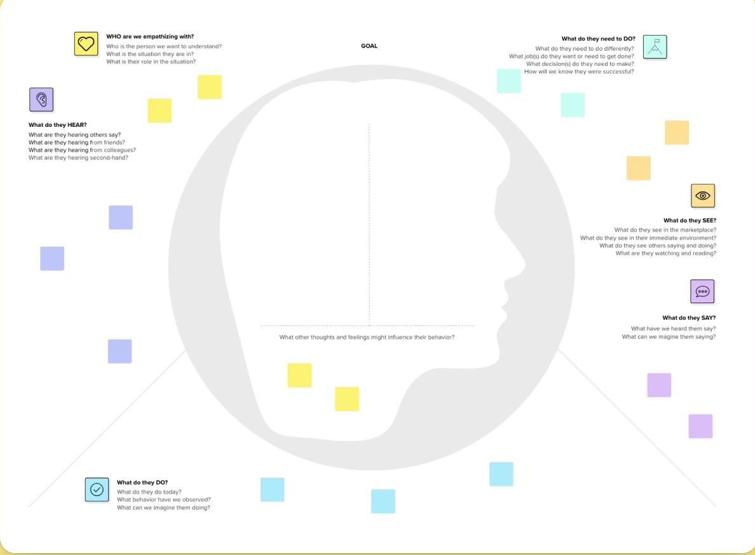

Reference: https://www.mural.co/templates/empathy-map-canvas

By deeply understanding users through empathy mapping, we identified the critical challenges support teams face in managing and assigning tickets. These insights revealed issues such as manual workload, unclear ownership, and inefficient prioritization. As a result, we designed a streamlined system using automation and analytics to ensure balanced assignments, reduced delays, and enhanced operational efficiency.

